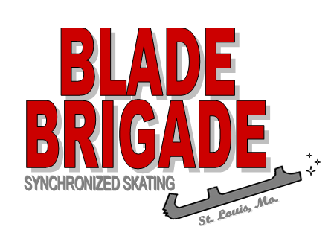

Synchronized Skating Teams

2023-2024 Tryouts

We’d love to have you come tryout for Blade Brigade! Any skater FS1 and above is invited to tryout.
Date: Sunday, April 30. 2023
Time: Registration begins at 10:45, skaters busy 11:15 – 12:45
Place: FSI Shark Tank Ice Arena, 6297 Lemay Ferry Road, St. Louis, MO 63129
Cost: $20 (to be collected at tryout – cash or check to Blade Brigade)
Deadline: Wednesday April 20, 2023
Return the attached form to Coach Niki Hrebec
    - Email as a PDF to coachniki.skating@yahoo.com or
    - US Mail: 1307 Spring Lilly Dr., High Ridge, MO 63049
What you need to know about try-out:
- All skaters need to wear appropriate skating attire.
- No skate rental is available.
- Tennis shoes are required for possible off-ice practice to learn footwork, no sandals or flip-flops.
- If you cannot make the scheduled time, alternate plans may be made by contacting Coach Niki. We prefer every effort to be made to attend tryouts as seeing skaters together is very important.
- Placement notification email or mail will take approximately 4-6 weeks.

What you need to know about joining the Blade Brigade teams:
- We skate at the Wayne C. Kennedy Recreation Complex for the regular season. Blade Brigade members must participate in group lessons or purchase a freestyle pass. Members 13 years and older must volunteer to assist in the learn-to-skate program.
- We will have summer practices at the FSI Shark Tank. We understand that families have vacations and other activities planned. A practice schedule will be handed out as soon as the teams are selected.
- Teams are divided by age and skill level. Fees for the season will depend on your team placement and the number of skaters on your team. For this purpose we need to know before tryouts if any skater only wishes to skate one team as it will affect team fees for everyone and where your skater will be placed. We encourage all of our skaters to skate two teams. Please keep in mind that certain teams are only offered to members skating more than one team.

We look forward to seeing you at tryouts!
Blade Brigade Tryout Registration Form 2023-2024
($20 fee to be turned in at Tryout)

Skater’s Name: Phone Number:

Address: ISI Number:

E-mail address: Highest ISI Level Passed:

Parent’s Names:

Birth Date: Age as of July 1, 2020:

Lesson Program and /or Private Lesson Coach:

Prior team experience:

In case of an emergency, please list a contact person and phone number:
I am interested in skating on only one team: ____
I am interested in skating on two teams: ____

Please mail to:
Attention: Blade Brigade, Niki Hrebec, 1307 Spring Lilly Dr., High Ridge, MO 63049
or e-mail: coachniki.skating@yahoo.com

* Everyone is REQUIRED to turn in a form by the deadline. If you are not available for 4/30/23, contact Niki to set something up, but please still turn in your form by the due date of April 20,2023.

